Bar graphs with math
Example:

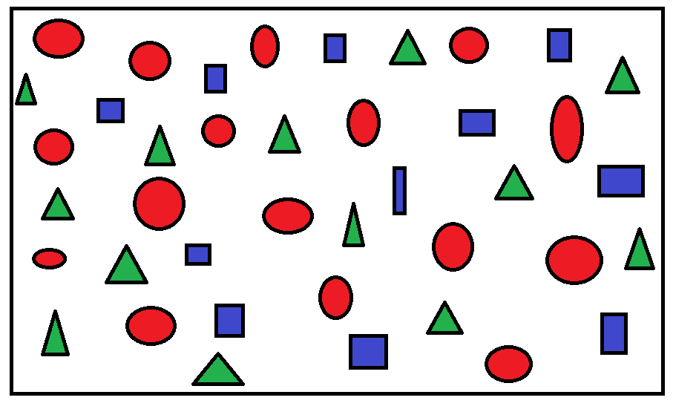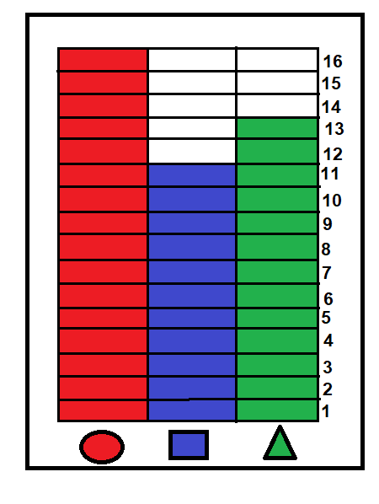
In the picture on the left there are sixteen (16) red circles, eleven (11) blue rectangles, and thirteen (13) green triangles. The bar graph on the right is showing the relationships between those numbers.
There are more red circles than there are blue rectangles. There are more red circles than there are green triangles. There are more green triangles than there are blue rectangles. There are less green triangles than there are red circles. There are less blue rectangles than there are red circles. There are less blue rectangles than there are green triangles.
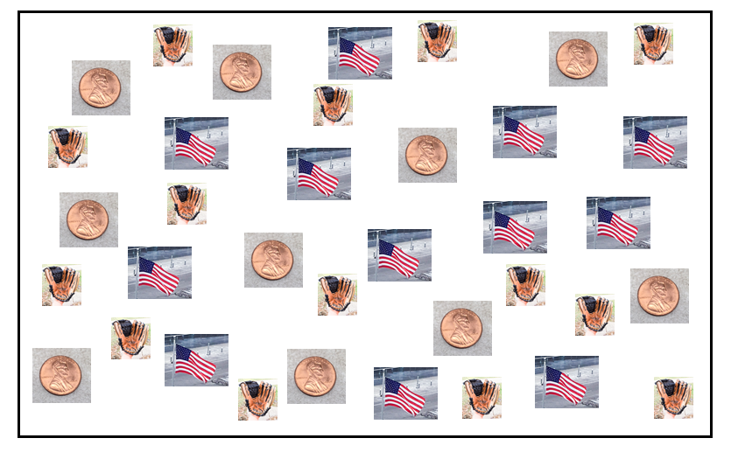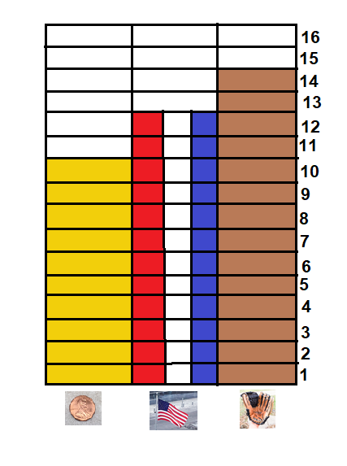
Circle the correct answer.

There are ________ mitts than there are flags. A. More B. Less
There are ________ flags than there are mitts. A. More B. Less
There are ________ pennies than there are flags. A. More B. Less
There are ________ pennies than there are mitts. A. More B. Less
There are ________ mitts than there are pennies. A. More B. Less
There are ________ flags than there are pennies. A. More B. Less

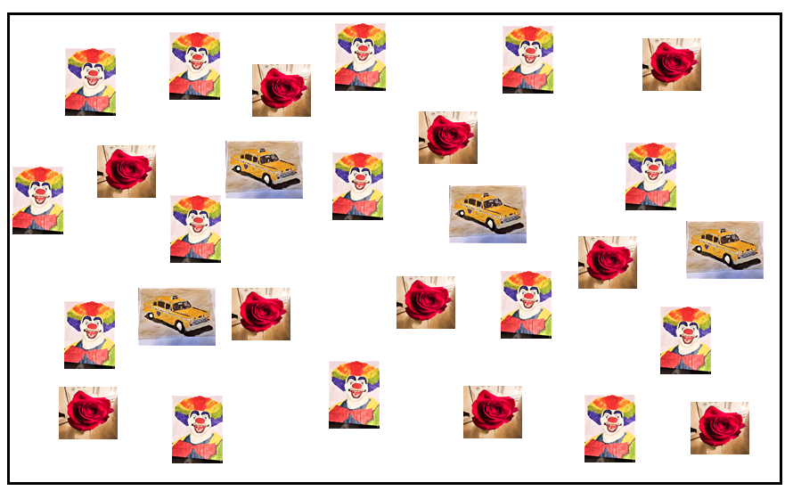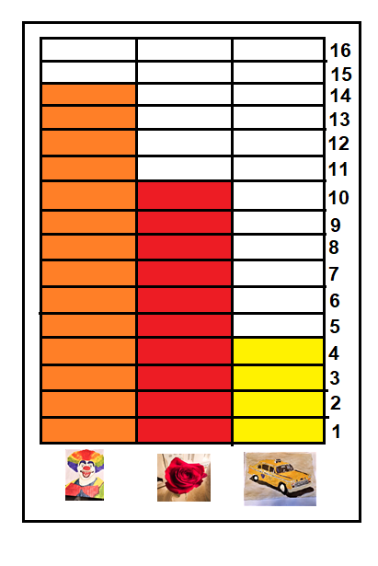

Circle the correct answer.

There are ________ roses than there are clowns. A. More B. Less
There are ________ cabs than there are clowns. A. More B. Less
There are ________ clowns than there are roses. A. More B. Less
There are ________ clowns than there are cabs. A. More B. Less
There are ________ roses than there are cabs. A. More B. Less
There are ________ cabs than there are roses. A. More B. Less

