0 1 2 3 4 5 6 7 8 9 10 11 12 13 14 15 16 17 18 19 20

Write the total number of items in the pictures presented:

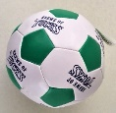
3 5
How many balls are there together in both sets of pictures? _________________.

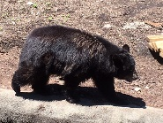
4 2
How many bears are there together in both sets of pictures? _________________.

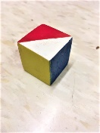
4 3
How many blocks are there together in both sets of pictures? ________________
0 1 2 3 4 5 6 7 8 9 10 11 12 13 14 15 16 17 18 19 20

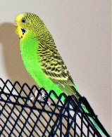
3
6
How many birds are there together in both sets of pictures? _____________.

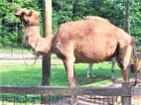
1
7
How many camels are there together in both sets of pictures? _______________.

0 1 2 3 4 5 6 7 8 9 10 11 12 13 14 15 16 17 18 19 20

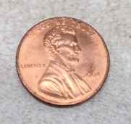
2 3
How many cents are there together in both sets of pictures? _______________.

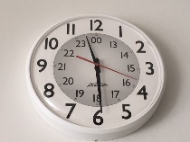
5 3
How many clocks are there together in both sets of pictures? _______________.

0 1 2 3 4 5 6 7 8 9 10 11 12 13 14 15 16 17 18 19 20

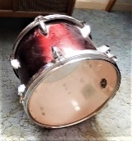
8 4
How many drums are there together in both sets of pictures? _______________.

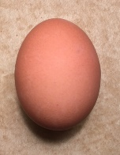
3 5
How many eggs are there together in both sets of pictures? _______________.

0 1 2 3 4 5 6 7 8 9 10 11 12 13 14 15 16 17 18 19 20

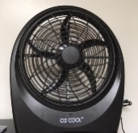
4 1
How many fans are there together in both sets of pictures? _______________.

